

Weston Auditorium
University of Hertfordshire, de Havilland Campus

Technical Specification

The Weston Auditorium de Havilland Campus University of Hertfordshire Hatfield
AL10 9EU UK

Capacity:

The Weston Auditorium has a capacity of 446 seats and 4 wheelchair spaces including 8 house seats.

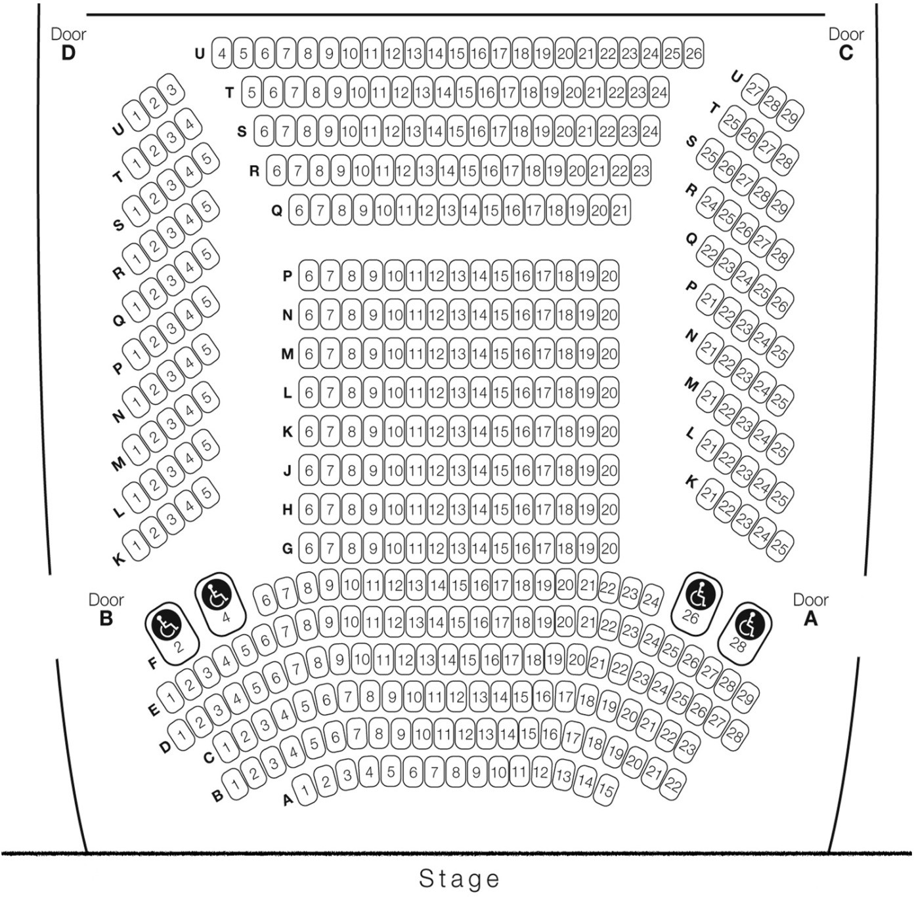

Wireless Internet Access

Wi-Fi access is available throughout the venue and via data points in the stage floor boxes.

The UH Network will require allocation of a username and password that will need to be requested prior to arriving on site from your Event Manager.

Stage Access: (External)

Loading Bay | Loading Bay  Step Height
Access for sets and technical equipment is via a single lorry  loading bay | 0.81m

Stage: (Internal)

Stage | Measurement
Stage Height from ground | 0.79m
Proscenium Arch, width | 11.67m
Total Stage Depth | 9.6m
Stage Depth to Mid-Stage Curtains | 6.9m
Total Stage Width (with movable panels in) | 16.00m
Total Stage Width incl. wings (front) wall to wall | 20.05m
Total Stage Width incl. wings (rear) wall to wall | 18m
Stage Height (stage to gantry) | 9.20m
Distance between each onstage lighting bar | 0.37m
Depth in front of screen | 3.49m

A detailed stage plan is available on request

Stage Floor:

- The stage floor is a flat wooden surface (not sprung).
- A black or grey dance floor covering is available on request.

Dressing Room Facilities:

There are 2 dressing rooms with showers:

1 x Male Dressing Room with shower.
1 x Female Dressing Room with shower.

1 x Disabled Toilet (Located back stage). 1 x WC (Located back stage).

Green Room:

Green Room for cast and crew may be available for use during your event. Please confirm with your Event Manager

Stage Masking:

- There are 8 hard black flats and an assortment of black borders and black legs.
- There is mid-stage black curtains that are permanently hung.

Stage Weights:

- 20 x 12.5kg
- 4 x 3kg Sausage weights
- 6 x 10kg counterweights

Please note that the venue uses the stage weights above as part of the venue masking. Not all weights may be available for you. Please confirm with the venue in advance if you wish to use any of our stage weights.

Stage Management:

- The Weston Auditorium has a prompt desk in the control room with cue lights fitted to the two dressing rooms, green room and cue light points left and right of stage.
- There is a hard wired system with points in the control room, two dressing rooms, green room, stage left, stage right and at the three live mixing positions.
- There are four sets of wireless comms available.

Q-Build Staging System:

The Q-Build decks are 750x750mm and made of best quality birch plywood, finished in UV cured, slip resistant acrylic lacquer as standard. Q-Build exceeds BS4875 (parts 5 & 6) for strength and stability tests and are proven for a range of stage and tiering layouts.

The following components are available for use in the Weston Auditorium but must be requested in advance through the UHArts Executive.

Item | Quantity
750mm Frames | 7
500mm Frames | 17
300mm Frames | 13
Square Decks | 36
30x750mm Single Bridge / Deck Units | 30
An assortment of handrails, chair stop plates, steps and fittings are available

Other Equipment:

Amadeus Conductors Podium with square carpet inlay, beech wood base and handrail.

Please note that some components may not be available when requested however we will endeavor to meet all requirements where possible.

Cyclorama:

Item | Quantity
White cyclorama at rear of stage (can be masked with black  tabs | 1

Power Supply:

Item | Quantity
63A - On rear wall of stage | 1
13A Floorbox - Stage Left, Stage Centre, Stage Right (Double) | 3
13A - On rear wall of stage | 4

Stage Floor Boxes:

Item (Stage Left, Stage Centre & Stage Right) | Quantity
13A Power | 2
BNC (Direct Copper) | 5
Network RJ45 (Password Required) | 2
Crestron | 2
XLR (Send Direct Copper) | 6
XLR (Return Direct Copper) | 2
Speakon (Foldback) | 2
VGA + 3.5mm Stereo Audio (Send - CAT 5 TX/RX) | 2
VGA + 3.5mm Stereo Audio (Return - CAT5 RX/TX) | 1
DVI-D (Send - Fibre) | 1
HDMI (Send - Fibre) | 1
DVI-D (Return - Fibre) | 1
HDMI (Return – Fibre | 1
BNC (Return – Direct Copper) | 1
Phono (Return – Direct Copper) | 1

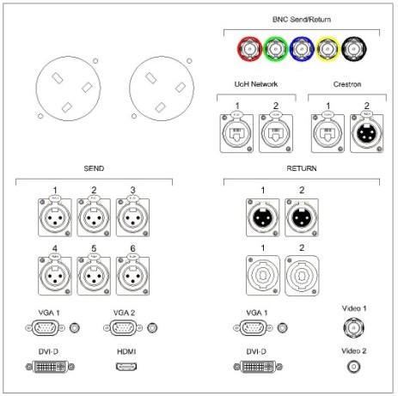
Floorbox Layout

There are two lids for the floorbox.
  - One solid for use when connections are not required.

  - One with slots to allow cable entry and exit, there is enough space to have this lid on when plugs are located in their sockets.

Stage Video Wall Box:

Item | Quantity
BNC (Direct Copper) | 5
Network RJ45 (Password Required) | 2
Crestron | 2
VGA + 3.5mm Stereo Audio (Send - CAT 5 TX/RX) | 2
VGA + 3.5mm Stereo Audio (Return - CAT5 RX/TX) | 1
DVI-D (Send - Fibre) | 1
HDMI (Send - Fibre) | 1
DVI-D (Return - Fibre) | 1
HDMI (Return – Fibre | 1
BNC (Return – Direct Copper) | 1
Phono (Return – Direct Copper | 1

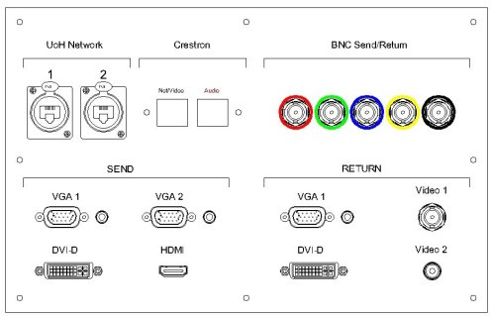

Stage Under Lip Connections:

Wall Box Layout

There are two lids for the floorbox.
- One solid for use when connections are not required.

- One with slots to allow cable entry and exit, there is enough space to have this lid on when plugs are located in their sockets.

Item | Quantity
VGA + 3.5mm Stereo Audio (Return - CAT5 RX/TX) | 3
XLR (Return Direct Copper) | 6
5A IEC Power Connection | 3

Stage Audio Wall Box:

Item | Quantity
XLR (Send Direct Copper) | 16
Speakon (Foldback) | 2

Gantry Audio:

Item | Quantity
XLR (Send Direct Copper) Over Audience | 4
XLR (Send Direct Copper) Over Stage | 2

Audio Hearing Loop:

Item | Quantity
TX
Ampetronic Loop Amplifier | 2
Ampetronic Phase Shifter | 1
RX
Ampetronic Loop Receiver | 2
Fostex Audio Amplifier | 1

The system covers the whole of the Weston Auditorium seating area and is monitored by two free-air receivers located in the auditorium at seating height (1.2M). This is then monitored in the control room on a Fostex monitor amplifier which has audio meters and an audio level control.

Control Room & Front of House (FOH) Sound:

Item | Quantity
Allen & Heath GL3800-824B | 1
Sennheiser Radio Microphone Receivers | 12
Sony Dual 31 Band Graphic Equaliser | 2
Sony MiniDisc (Player / Recorder) | 1
Marantz Compact Flash MP3 (Player / Recorder) | 1
Tascam CD (Player) | 1
Tascam CDR (Player / Recorder) | 1
Roland Digital Snake (16 Channel) | 1
Denon Surround Sound Processor | 1
Crown Amplifier (5.1 Surround System) | 4
EV Speakers (5.1 Surround System) | 8
Sabine Feedback Eliminator | 1
Lexicon Effects Processor | 1
QSC Amplifier | 10
Martin Audio WS2A (Sub) | 2
Martin Audio WT2 (Front of House) | 4
Martin Audio WTUB (Audience Fill) | 2
Martin Audio LE350 (Wedge) | 6
Martin Audio W0.5 (Stage Fill) | 2

There are 3 live mixing positions at the rear of the Weston Auditorium (Stage Left, Stage Centre, and Stage Right); these can be made available by prior arrangement and will require the removal of some seating.

This does not include a mixing console but one may be available by prior arrangement.

Microphones & DI Boxes:

Item | Quantity
Sennheiser sk2000 lapel microphone | 7
Sennheiser sk2000 handheld microphone | 3
AKG C1000S | 2
AKG C747 | 8
Audio Technica Cardioid AT4041 | 2
Audio Technica Unipoint AT853A | 2
Shure SM57 | 5
Shure SM58 | 5
Beyer Dynamic Opus 54 | 3
Behringer Active direct Inject Box (Ultra DI) | 6

Control Room & Front of House (FOH) Video:

Item | Quantity
Panasonic AW-HE100E High Definition Pan/Tilt Camera | 4
Panasonic AW-RP400L Remote Camera Controller | 1
Panasonic AW-CB400L Camera Colour Corrector | 1
Panasonic AW-HS400A Hi Definition Vision Mixer | 1
Sony DVD (Player / Recorder) | 2
Pioneer Blu-Ray Player | 1
JVC BR-HD50 HDV (Player / Recorder) | 1
JVC SR-DVM700 DV, DVD, HDD (Player / Recorder) | 1
Panasonic AG-DV2700 DV (Player Recorder) | 1
BlackMagic Hard Disc Recorder | 1

Video Conferencing:

Item | Quantity
Polycom ViewStation FX | 1

The video conferencing system is by prior arrangement and is IP based.

Video Streaming:

Item | Quantity
Computer Based Streaming System using Real Producer | 1

The video streaming system is by prior arrangement with the University of Hertfordshire.

Video Projection:

Item | Quantity
Christie HD-M10K HD Projector (Blended System) | 2
Christie Spyder 344 | 1
11.8M x 3.7M Projection Screen | 1

The Blended Spyder system will allow you to have a static background image of your design. If you wish to have your designers do this then the pixel ratio you will need is 3392 x 1080.

Over this background you can display up to four live images anywhere in this pixel space, and anywhere you require them to be.

The Christie Spyder automatically handles the matrix signal switching from the analogue and digital matrixes, which will give up to 64 inputs.

Video Other:
We are able to patch other signals in to our system either from the stage or control room these are: Analogue:
  - Composite Video
  - S-Video (Y/C)
  - Component (YUV)
  - RGB & Sync
  - VGA (RGBHV)

Digital:

- SDI
- HDSDI
- DVI-D
- HDMI

Lighting:

Item | Quantity
Lighting Desks
ETC ION | 1
Strand 520i Lighting Console | 1
Zero 88 Bullfrog Lighting Console | 1
Lighting
ETC Source 4 Profile Spotlight 15° to 30° Zoom | 20
ETC Source 4 Profile Spotlight 25° to 50° Zoom | 12
Coemar LEDKO (source 4 front barrel) | 2
ETC Source 4 PAR Spotlight 575w | 14
Strand Quartet Fresnel Spotlight 650w | 8
Strand Coda 1/500 Cyc Flood | 8
Strand Cantata F 1200w Fresnel | 18
Spotlight Area Fresnel 1200w | 12
Selecon Hui Cyc Flood | 8
Thomas PAR 64 PAR Can (Black) CP62 | 12
Floorlite PAR 64 Par Can (Silver) | 12
PAR 16 (Silver) | 4
Vision PAR 30 (Silver) | 20
Chauvet Colorado | 10
IPIX BB4 LED Lantern | 8
JB-Lighting A7 LED wash | 4
Martin MAC 575 | 2
Martin MAC 350 Entour | 2
Piccolo 1KW spotlight with effects wheel | 2
Martin-Atomic 3000 | 2
Selcon Pacific Followspot | 2
Pani HMV 1202/35 Followspot | 2
Croma-Q CQ1 Colour Changer | 26
6 Circuit 1-16A Internally Wired Fly Bars | 14
4 Circuit 4-16A Internally Wired Fly Bars | 2
Dimmers
Dimmable Channels | 192
Non-Dimmable Channels | 16

Please note that all sockets and internally wired bars (IWB) are all 16A Ceeform. A limited supply of converters (15A Round - 16A Ceeform) are available.

Visual Effects:

Item | Quantity
Jem ZR 24/7 Hazer | 1
Jem ZR 33 Hi-Mass Smoke Machine (DMX) | 1

Contact Details for Information Hertfordshire, Events and Technical Support:

Position | Name | Phone | Email
Events and Technical Support Manager | Stephen Bell | 01707 284471 | s.t.bell@herts.ac.uk
Helpdesk |  | 01707 284678 | helpdesk@herts.ac.uk
Events Technician | Emma Moloney | 01707 283251 | e.moloney@herts.ac.uk
Events Technician | James Scutt | 01707 285752 | j.a.scutt@herts.ac.uk

Please note

The equipment listed within this document cannot be guaranteed available for your event. Please contact the Events and Technical Support Team prior to your event to agree your technical requirements.

